Tornado in the jar
What we need:
- a jar with a lid, hot water, a small amount of dishwashing liquid 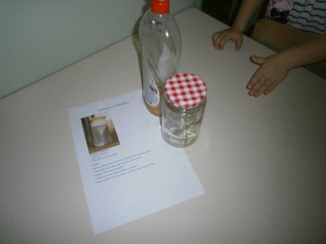
1. Fill the jar with warm water almost to the top.
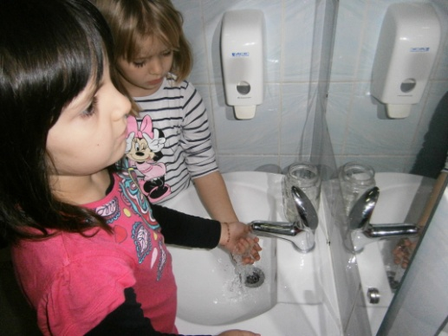
2. Put several drops of dishwashing soap into the water.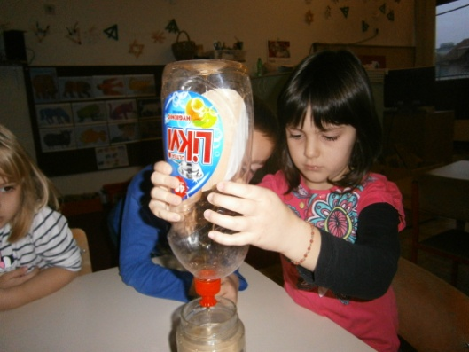
3. Firmly close the lid and vigorously spin the jar into the circle holding it horizontally with both hands.
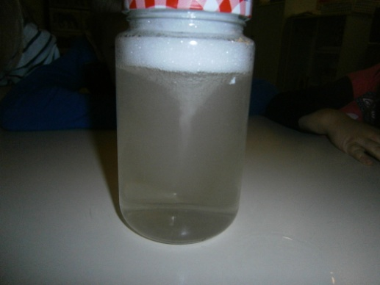
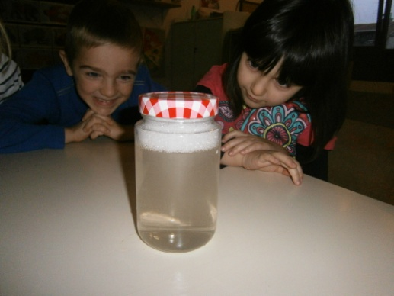

The cloud in the jar
It is needed: jars, hot water, ice, aluminum foil
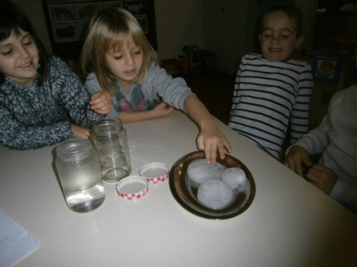
In the jar, pour hot water (up to 3 cm high), cover the opening with aluminum foil and place it on ice.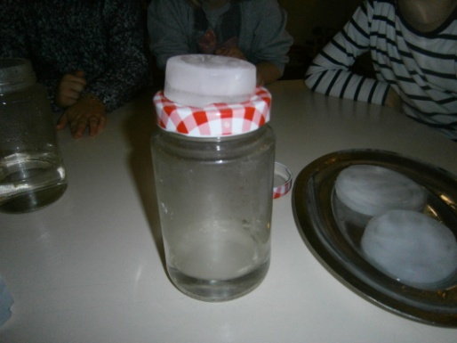 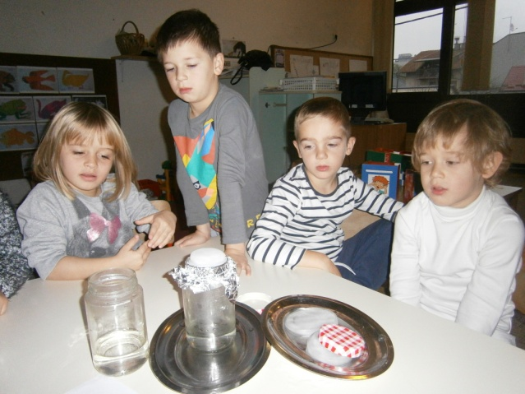
At the top of the jar will form a cloud, an ornate part. In nature, clouds are formed when warm, moist air cools so formed tiny droplets that form the cloud.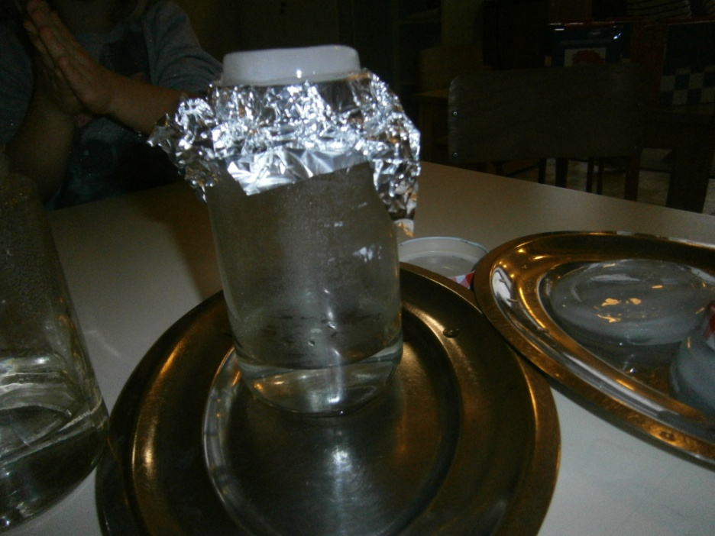

Freezing water into ice
Required: unopened plastic bottles with water, freezer
- Take the vials in the freezer for 2 and a half hours. The water is cooled below 0 degrees C but it will not completely freeze due to its purity. When we wipe the hard substrate bottle, the water is now turning into ice.
